## **Introduction to Photoplethysmography (PPG) and Heart Rate Variability (HRV)**

#### **Abstract**

Photoplethysmography (PPG) is a widely-used optical technique in modern wearables to monitor heart rate, while Heart Rate Variability (HRV) is an emerging metric that provides deeper insights into cardiovascular and autonomic nervous system health. This article introduces PPG, its mechanism, and its significance in measuring heart rate, along with a detailed explanation of HRV, its physiological basis, and its importance as a health metric. We also discuss how leading brands like WHOOP utilize PPG and HRV to optimize health monitoring.

#### **Introduction**

The demand for non-invasive health monitoring technologies has surged, driven by advancements in wearables and mobile health applications. PPG is now an integral part of modern health tracking systems due to its ease of use and cost-effectiveness. Typically embedded in smartwatches and other wearables, PPG offers a convenient way to measure heart rate continuously, helping users monitor key health metrics.

With the rise of health-conscious consumers, wearable devices have transformed how we monitor our vital signs. Brands like **WHOOP**, **Garmin**, and **Oura** have become leaders in leveraging **Photoplethysmography (PPG)** and **Heart Rate Variability (HRV)** to provide continuous insights into a user's overall well-being, recovery, and stress levels. These technologies offer a non-invasive way to gather critical health data, making health tracking more accessible to the general population.

#### **What is Photoplethysmography (PPG)?**

Photoplethysmography (PPG) is an optical method used to measure blood volume changes within the microvascular bed of tissue. This technique leverages the fact that blood absorbs more light than surrounding tissues, enabling the detection of changes in blood flow. As the heart pumps blood through the body, the blood volume fluctuates, causing corresponding changes in light absorption. This variation is captured as a PPG signal.

PPG is primarily used in devices such as smartwatches, smart rings, and smart bands to provide continuous heart rate monitoring. Its integration into wearable technology has made it a popular and accessible option for real-time health monitoring.

#### **How PPG Works**

PPG operates by emitting light (usually from an LED) into the skin and measuring the amount of light either transmitted or reflected using a photodetector. The light is absorbed by blood and tissues, with the amount of light absorbed varying according to the volume of blood present at any given time. The PPG waveform mirrors these fluctuations, where peaks represent systole (the heart's contraction phase), and valleys represent diastole (the relaxation phase).

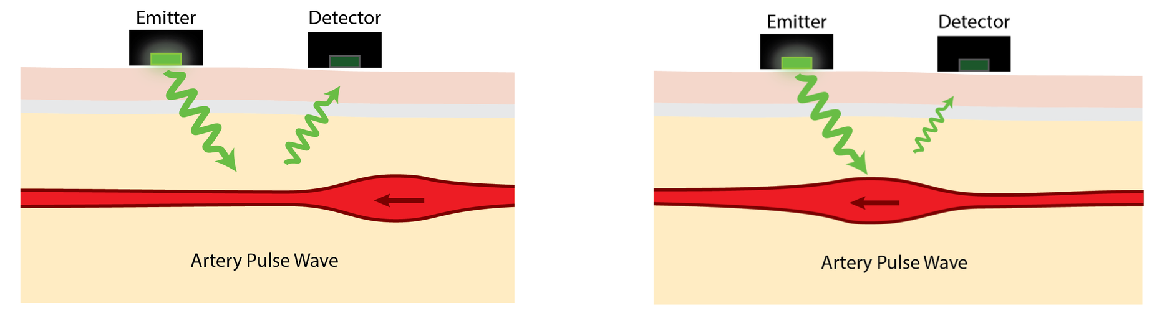

*Image 1: Basic PPG System Setup*

The typical PPG setup involves a light source and a photodetector working together to measure blood volume changes.

There are two common methods to measure PPG signals:

* **Transmission Mode:** Light passes through the tissue (e.g., fingertip or earlobe), and the sensor detects the transmitted light.
* **Reflectance Mode:** Light is reflected off the skin, and the sensor measures the reflected light. Reflectance mode is commonly used in wearables like smartwatches and smart bands.

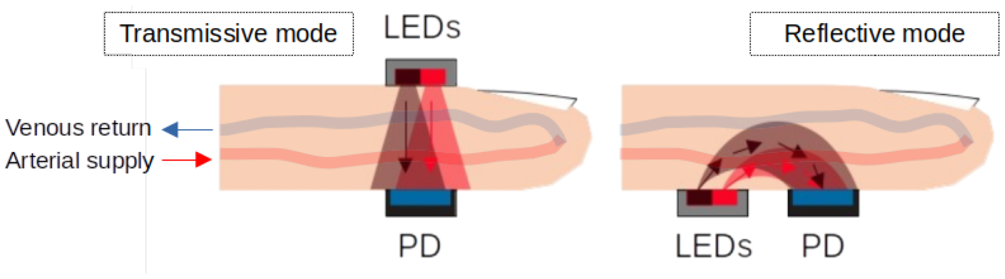

*Image 2: Methods to measure PPG signal*

#### **Science Behind PPG**

PPG captures changes in light absorption caused by the blood volume pulses produced by the heartbeat. The signal can be further processed to determine heart rate, oxygen saturation, and other parameters. The real-time nature of PPG makes it highly suitable for continuous monitoring.

#### **Significance of PPG Data and Optimal Collection Methods**

PPG data, when collected accurately, provides a wealth of information about a person's cardiovascular health. Wearable devices like smartwatches and smart bands are now the most common platforms for PPG-based monitoring, but the earlobe is considered one of the best locations for collecting reliable PPG data due to its excellent blood flow and minimal motion artifacts. However, the wrist (via smartwatches and bands) is a more feasible and widely adopted option due to its practicality and user convenience.

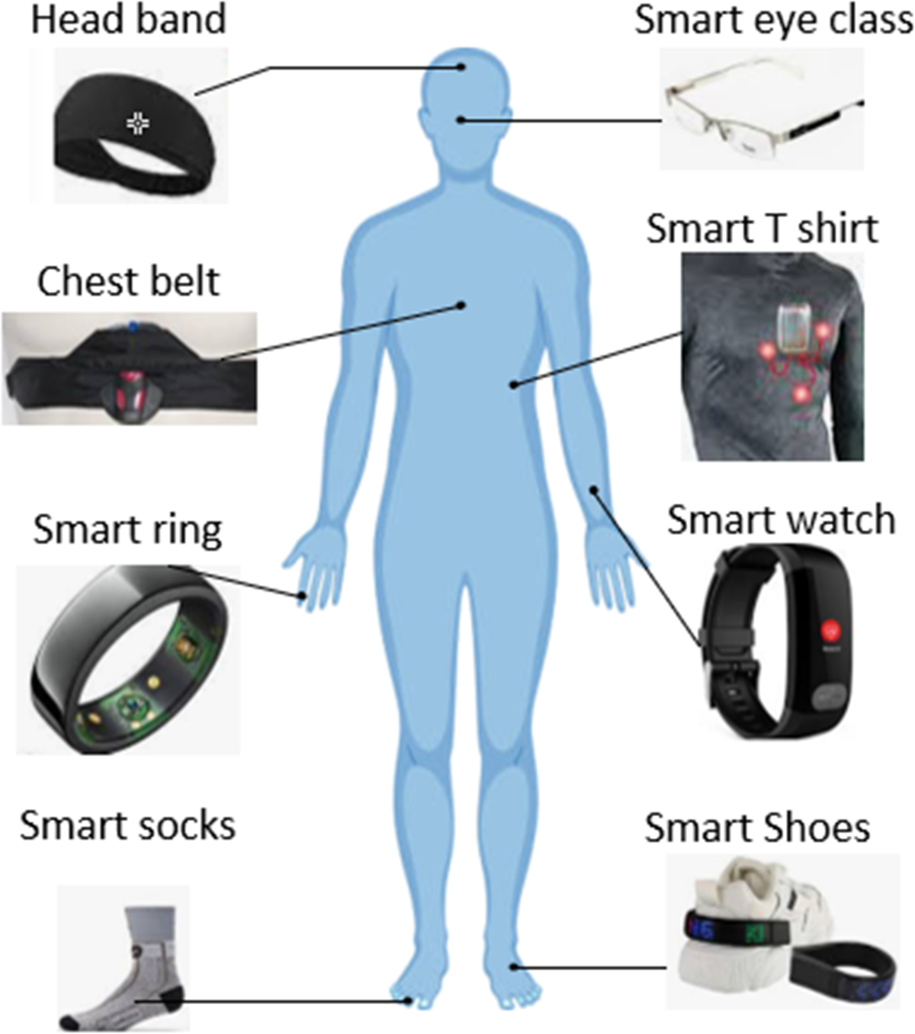

*Image 3: PPG Data Collection through a variety of devices*

Wearable devices like smartwatches provide convenient and continuous PPG data collection, though the earlobe is often considered a superior location for signal accuracy.

Optimal PPG data collection relies on minimal motion, stable light contact, and reduced environmental interference. Advances in wearable technology now allow continuous, motion-compensated data collection from the wrist, enabling large-scale health tracking in everyday activities.

#### **Applications of PPG in Health Monitoring**

One of the most straightforward applications of PPG is heart rate monitoring. Using PPG data, wearables can derive accurate heart rate information, which forms the foundation for many advanced health metrics and use cases.

#### **Key Applications:**

* **Heart Rate Monitoring:** The primary and most reliable use case for PPG is continuous heart rate tracking, now available in most wearable devices.
* **Stress Measurement:** PPG data can also be used to estimate stress levels by analyzing heart rate variability (HRV) and blood flow patterns. Many wearables now offer built-in stress monitoring based on these calculations.
* **Sleep Quality Tracking:** PPG can provide insights into sleep cycles by tracking heart rate fluctuations throughout the night, offering data on sleep stages and sleep quality.
* **Energy and Recovery Metrics:** Fitness-oriented wearables utilize PPG data to assess physical exertion and recovery time, translating the information into an “energy score” for users.
* **Drowsiness Detection:** Some devices are using PPG data to detect drowsiness by monitoring changes in heart rate patterns, especially for drivers and workers in high-risk environments.

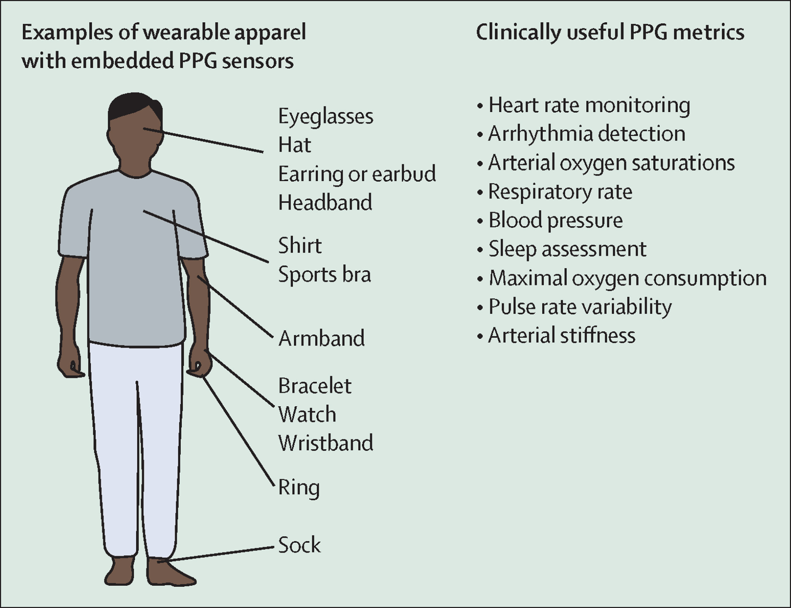

*Image 4: Health Monitoring Applications Using PPG*

Advanced applications of PPG include heart rate monitoring, stress analysis, and sleep tracking, with innovations continuing to emerge in wearable technology.

Many leading wearable companies are continually enhancing their features based on PPG data, offering more personalized insights for users and expanding the capabilities of health monitoring.

#### **Introduction to Heart Rate Variability (HRV)**

While heart rate provides a snapshot of cardiovascular activity, **Heart Rate Variability (HRV)** offers a more nuanced view of autonomic nervous system (ANS) functioning. HRV is the measure of the variation in time intervals between consecutive heartbeats, also known as **RR intervals**. A high HRV typically reflects a well-functioning parasympathetic (rest-and-digest) nervous system, whereas a low HRV may indicate heightened sympathetic (fight-or-flight) activity.

#### 

#### *Image 5: HRV as a Time Interval Measurement*

HRV measures the variation in time between consecutive heartbeats (RR intervals).

#### **Physiological Basis of HRV**

HRV is governed by the balance between the **sympathetic nervous system (SNS)** and the **parasympathetic nervous system (PNS)**. The SNS is responsible for activating the body's fight-or-flight response, increasing heart rate, and preparing the body for stressful situations. Conversely, the PNS helps the body relax and recover by lowering the heart rate.

* **High HRV**: Indicates a greater level of parasympathetic activity, reflecting an ability to recover from stress, physical exertion, or emotional challenges. It is generally associated with good cardiovascular health, resilience, and fitness.
* **Low HRV**: Suggests dominance of the sympathetic system, which can result from stress, fatigue, illness, or overtraining. Low HRV can be an indicator of poor recovery, stress, or potential health issues.

In the world of wearable devices, brands like **WHOOP** and **Elite HRV** use HRV to track recovery and stress levels, allowing users to make data-driven decisions about exercise, rest, and recovery.

#### **Why HRV is an Important Health Metric**

HRV provides insight into the dynamic interplay between the sympathetic and parasympathetic nervous systems, making it a critical marker for:

* **Recovery Tracking**: Athletes, fitness enthusiasts, and even general users benefit from HRV as an indicator of recovery. A higher HRV indicates better recovery and readiness for physical activity.
* **Stress Management**: HRV offers a real-time window into how stress affects the body. A lower HRV may indicate chronic stress, poor sleep, or inadequate recovery from physical or mental exertion.
* **General Health**: HRV is increasingly used as a marker for overall health, helping to predict the onset of cardiovascular issues or other chronic conditions. Individuals with consistently low HRV are more likely to suffer from cardiovascular diseases or mental health issues like anxiety.

#### 

#### Image 6: HRV's Role in Health Monitoring

HRV provides insights into recovery, stress, and overall cardiovascular health.

#### **Applications and Use Cases of HRV**

The following use cases illustrate how HRV is applied in various aspects of health monitoring:

* **Sleep Quality**: HRV data is often combined with sleep metrics to provide insights into sleep cycles and the quality of rest. Wearable devices use this data to help users improve sleep habits.
* **Stress and Emotional Health**: As stress increases, HRV tends to decrease, providing a quantifiable measure of emotional strain. Some HRV-focused wearables offer guided breathing exercises to help improve HRV and reduce stress.
* **Fitness and Training**: Athletes use HRV to track recovery and prevent overtraining. A low HRV may indicate that the body hasn’t recovered sufficiently, signaling the need for rest before the next workout.
* **Energy Levels and Fatigue**: HRV can be used to predict energy levels and identify signs of fatigue. As HRV decreases, fatigue sets in, signaling the need for rest or reduced activity.

Many companies are building features around HRV to offer users real-time feedback on these metrics. For instance, **Oura Ring** and **WHOOP** both provide users with a "recovery score" based on HRV, sleep quality, and activity levels, allowing for more personalized recommendations around exercise and rest.

#### **Research Connecting PPG and HRV**

While PPG was initially developed for heart rate measurement, recent studies have demonstrated its ability to derive HRV information. The use of PPG to measure HRV is explored and found that PPG-derived HRV could serve as an alternative to traditional electrocardiogram (ECG) methods for long-term monitoring. This is especially useful for wearable devices that prioritize portability and convenience over clinical-grade accuracy.

Studies have also explored using PPG to derive HRV metrics under various conditions, including exercise, rest, and sleep. As wearables become more sophisticated, algorithms that analyze PPG signals are improving in accuracy, enabling more precise HRV readings. This opens the door for PPG-based HRV monitoring in large-scale, non-clinical settings, offering both athletes and everyday users a powerful tool for managing their health.

#### **Conclusion**

Photoplethysmography (PPG) and Heart Rate Variability (HRV) together offer a comprehensive approach to understanding and managing health. PPG provides accurate, continuous heart rate monitoring, while HRV adds deeper insights into the autonomic nervous system, stress levels, recovery, and overall health. Wearable devices like those offered by WHOOP, Garmin, and Oura have integrated both metrics to help users make informed decisions about their fitness and well-being.

Despite challenges like motion artifacts, advancements in wearable technology are continually improving the accuracy and quality of PPG signals, enabling more reliable HRV measurements. As research in PPG and HRV progresses, their applications in areas such as stress management, sleep analysis, and personalized health monitoring will continue to expand, playing a critical role in preventive healthcare.

#### 

#### **References**

1. Elite HRV (2022). What is Heart Rate Variability? Retrieved from<https://elitehrv.com/what-is-heart-rate-variability>
2. Pinheiro N, Couceiro R, Henriques J, Muehlsteff J, Quintal I, Goncalves L, Carvalho P. Can PPG be used for HRV analysis? Annu Int Conf IEEE Eng Med Biol Soc. 2016 Aug;2016:2945-2949. doi: 10.1109/EMBC.2016.7591347. PMID: 28268930. Retrieved from<https://pubmed.ncbi.nlm.nih.gov/28268930/>
3. Empatica (2020). The Clinical Importance of Heart Rate Variability. Retrieved from<https://www.empatica.com/blog/the-clinical-importance-of-heart-rate-variability.html>
4. Monitoring Heart Rate Variability for Better Athletic Ability (2020). Retrieved fromhttps://www.testandmeasurementtips.com/monitoring-heart-rate-variability-for-better-athletic-ability-faq/
5. Kampert, S., & Gerber, M. (2023). Mental health and heart rate variability: How are they related? *Journal of Public Health*, 31, 125-134. doi:10.1007/s10389-023-01893-6. Retrieved from<https://link.springer.com/article/10.1007/s10389-023-01893-6>
6. The Lancet Digital Health. (2023). Heart rate variability and digital health. *The Lancet Digital Health*, Vol 5 Iss 7. Retrieved from<https://www.thelancet.com/journals/landig/article/PIIS2589-7500%2823%2900087-0/fulltext>
7. Oura Support. (n.d.). Heart Rate Variability. Retrieved fromhttps://support.ouraring.com/hc/en-us/articles/360025441974-Heart-Rate-Variability
8. WHOOP (2021) Heart Rate Variability (HRV): What is it & How to Improve It. Retrieved from<https://www.whoop.com/us/en/thelocker/heart-rate-variability-hrv/>
9. Clint R. Bellenger, Dean J. Miller, Shona L. Halson, Gregory D. Roach, Charli Sargent (2021). Validation of WHOOP device in measuring heart rate variability. Retrieved from<https://www.ncbi.nlm.nih.gov/pmc/articles/PMC8160717/>